San Francisco 49ers Performance Analysis

This report analyses the performance of the San Francisco 49ers (SF) using game-level data from 2014 – 2024. The aim is to identify the key factors that influence success, explore performance patterns across recent seasons, and use predictive modelling to estimate future outcomes. The report presents exploratory insights, visualisation, and a win rate projection for the 2025 season.

# Data and Methodology

Game-level data for the San Francisco 49ers was collected covering the 2014–2024 NFL seasons. Each record included offensive and defensive statistics (such as yards gained and allowed, turnovers, and points scored and conceded), contextual information (home or away, opponent, week), and outcomes (win or loss). Data was cleaned and standardised by restructuring column names, correcting data types, and removing non-regular fixtures. Derived attributes were created, including point differential, turnover differential, and binary indicators for win/loss and home/away.

To capture form and momentum, rolling averages of the previous three games were calculated for key measures such as points scored, points allowed, total yards, and turnover differential. Opponent strength was represented using opponent win percentage, while the 49ers’ own pre-game win percentage was included as a measure of current season performance.

Predictive modelling focused on win/loss outcomes. A Random Forest classifier was trained on data from 2014–2023 and tested on unseen games from 2024. Model performance was assessed using accuracy, ROC AUC, and log loss, ensuring both reliability and interpretability.

# 2023 Season Exploratory Insights

Initial analysis of game-level data highlighted several patterns in the 49ers’ recent performance (Figure 1). In the 2023 season, the team’s offence improved in the second half of the year, averaging over 31 points per game compared to 27 in the opening weeks. Total yardage also increased later in the season, while the defence maintained consistent strength by holding opponents to around 17 points per game on average.

Looking at individual games, shown in Table 1, the highest-scoring performance occurred in Week 15 of the 2023 season, when the 49ers scored 45 points against the Arizona Cardinals. This reflected both the weakness of the opponent (a team with only three wins at that stage) and San Francisco’s offensive efficiency, gaining over 400 yards and forcing two turnovers. By contrast, the lowest-scoring game came in Week 6 against the Cleveland Browns, a team with one of the strongest defences in the league. The 49ers were held to just 17 points and 215 total yards, despite generating two takeaways on defence.

Taken together, these patterns highlight the importance of opponent quality and turnover differential in shaping outcomes. Strong offensive production against weaker teams enabled dominant wins, while elite defensive opposition constrained the team’s scoring potential.

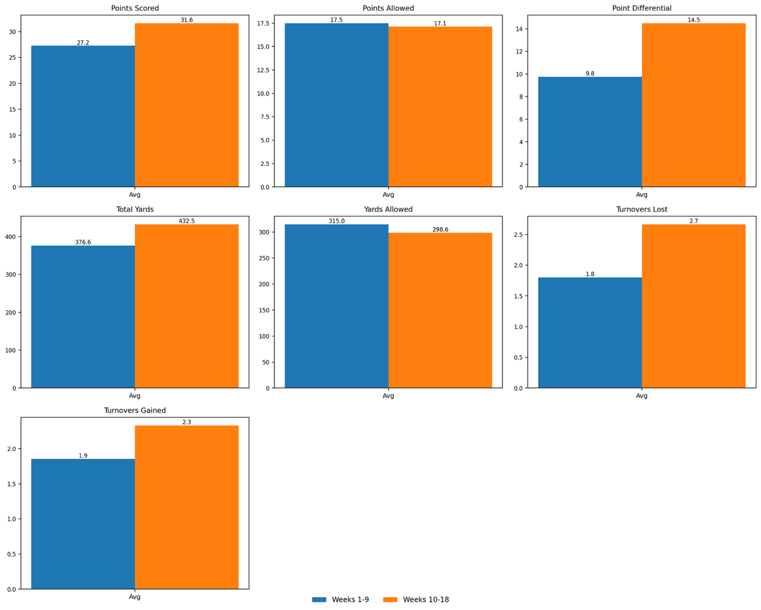

**Figure 1** - Statistics for season 2023 comparing first and second half

**Table 1** - Summary stats for 29ers' best and worst performing games

|  |  |  |  |  |  |  |
| --- | --- | --- | --- | --- | --- | --- |
| **Game** | **Opponent** | **Venue** | **Score (SF-Opp)** | **Total yards (SF)** | **Turnovers (SF/Opp)** | **Opponent Record at Kick-off (W – L)** |
| Week 15 | Arizona Cardinals | Away | 45-29 | 406 | 0 / 2 | 3-11 |
| Week 6 | Cleveland Browns | Away | 17-19 | 215 | 1/2 | 2-2 |

# 4. Predictive Modelling Findings

Predictive analysis focused on classifying outcomes (win or loss) using historical performance and contextual data. A Random Forest classifier was trained on games from 2014–2023 and tested on unseen fixtures from 2024. The model achieved strong performance, with an accuracy of 75% and an ROC AUC of 0.90, indicating that it was highly effective at distinguishing wins from losses.

The ROC curve (Figure 2) demonstrates the model’s reliability, showing a high true positive rate with relatively few false positives. The confusion matrix (Figure 3) shows that the model correctly predicted 8 losses and 4 wins, while misclassifying 2 losses as wins and 2 wins as losses. This provides a balanced picture of how the model performed on actual 2024 games: most outcomes were classified correctly, and the errors were relatively few.

Analysis of feature importance (Figure 4) highlighted that opponent strength, measured by win percentage prior to each game, was the most influential factor in determining outcomes. The 49ers’ own pre-game win percentage was also highly predictive, followed by offensive yardage, recent scoring output, and turnover differential. Defensive metrics such as yards allowed also contributed meaningfully, while home-field advantage was found to play only a minor role. These findings reinforce the importance of offensive consistency and turnover control, particularly when facing stronger opponents.

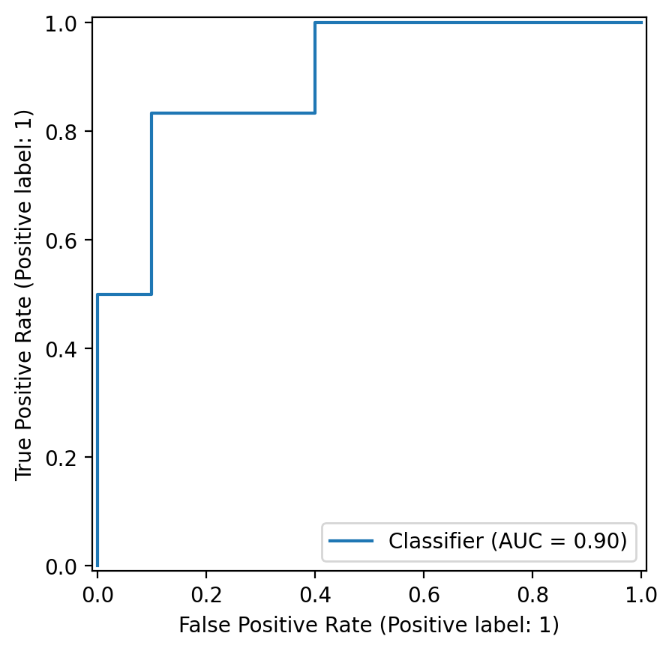

**Figure 2** - ROC Curve – Random Forest Classifier (Win/Loss)

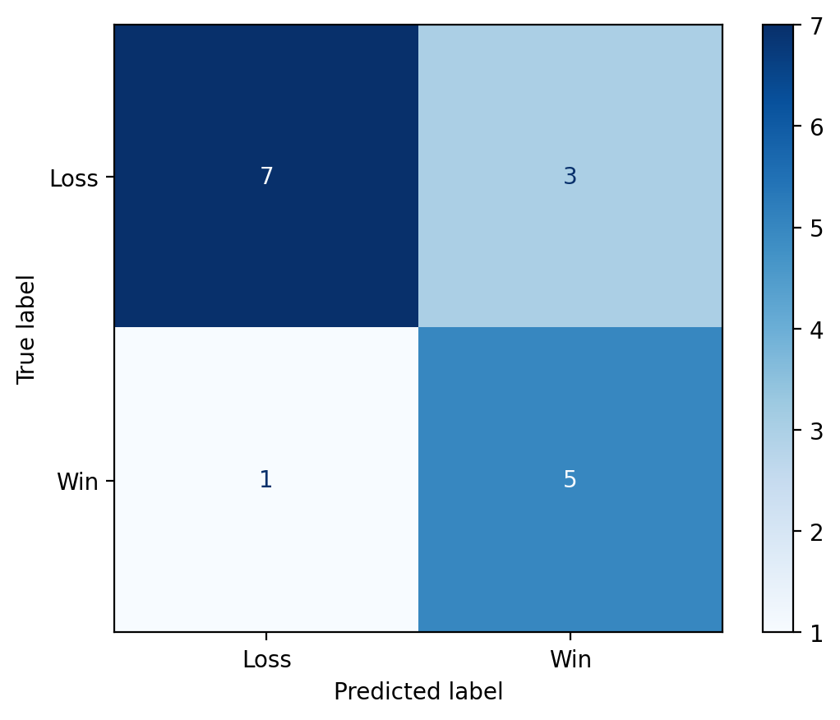

**Figure 3** - Confusion Matrix of Random Forest Classifier for the 2024 Season.

**Figure 4** - Feature Importance of the Random Forest Classifier.

# 5. Trend and Future Projection

Examining win rates over the 2014–2024 period shows how the 49ers’ performance has fluctuated between seasons (Figure 5). After recording a 50%-win rate in 2014, the team entered a period of decline, falling to just 12.5% in 2016 and 25% in 2018. A breakout season followed in 2019 with an 81%-win rate, before another downturn in 2020. More recently, the 49ers produced three consecutive winning seasons from 2021–2023, including a 76%-win rate in 2022, before slipping again to 37.5% in 2024.

A linear trend line fitted across this period suggests a projected 2025-win rate of approximately 67%, equivalent to around 11–12 wins in a 17-game schedule. This projection (Figure 5) indicates a likely recovery from the 2024 slump, aligning more closely with the strong performances of recent years. Combined with the predictive modelling results, this suggests that maintaining offensive yardage and turnover control will be key to sustaining playoff-level performance.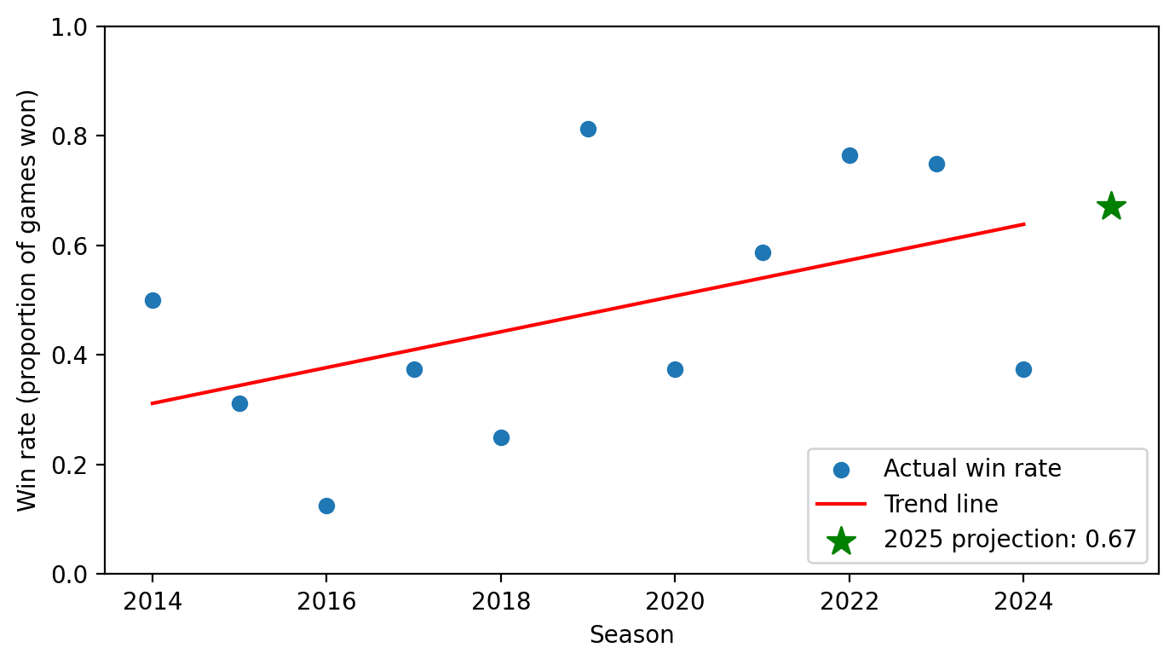

**Figure 5** - 49ers' win rate for each season between 2024-2024 with a predicted win rate of 0.67 for the 2025 season using linear trend.

# 6. Conclusion

This analysis has highlighted the key factors influencing the San Francisco 49ers’ performance and projected their likely trajectory for the upcoming season. Exploratory insights showed that offensive yardage, turnover differential, and opponent strength consistently shaped game outcomes. Predictive modelling reinforced these findings, with a Random Forest classifier achieving strong performance in distinguishing wins from losses and feature importance analysis confirming the influence of opponent win percentage, recent form, and offensive production.

Examining long-term trends revealed a pattern of fluctuation, from historic lows in 2016 to peaks in 2019 and 2022, followed by a downturn in 2024. A simple linear projection suggests that the 49ers are likely to recover in 2025, with an expected win rate of around 67% (equivalent to 11–12 wins). Taken together, these findings indicate that maintaining offensive consistency and controlling turnovers will be critical for sustaining playoff-level performance, while also highlighting the impact of opponent strength on game outcomes.